**DIGITAL-NURTURE-4.0- JAVA FSE**

**WEEK-2 PL/SQL PROGRAMMING**

**Creating the tables**

**code**

*CREATE TABLE Customers (*

*CustomerID NUMBER PRIMARY KEY,*

*Name VARCHAR2(100),*

*DOB DATE,*

*Balance NUMBER,*

*LastModified DATE*

*);*

*CREATE TABLE Accounts (*

*AccountID NUMBER PRIMARY KEY,*

*CustomerID NUMBER,*

*AccountType VARCHAR2(20),*

*Balance NUMBER,*

*LastModified DATE,*

*FOREIGN KEY (CustomerID) REFERENCES Customers(CustomerID)*

*);*

*CREATE TABLE Transactions (*

*TransactionID NUMBER PRIMARY KEY,*

*AccountID NUMBER,*

*TransactionDate DATE,*

*Amount NUMBER,*

*TransactionType VARCHAR2(10),*

*FOREIGN KEY (AccountID) REFERENCES Accounts(AccountID)*

*);*

*CREATE TABLE Loans (*

*LoanID NUMBER PRIMARY KEY,*

*CustomerID NUMBER,*

*LoanAmount NUMBER,*

*InterestRate NUMBER,*

*StartDate DATE,*

*EndDate DATE,*

*FOREIGN KEY (CustomerID) REFERENCES Customers(CustomerID)*

*);*

*CREATE TABLE Employees (*

*EmployeeID NUMBER PRIMARY KEY,*

*Name VARCHAR2(100),*

*Position VARCHAR2(50),*

*Salary NUMBER,*

*Department VARCHAR2(50),*

*HireDate DATE*

*);*

**output**

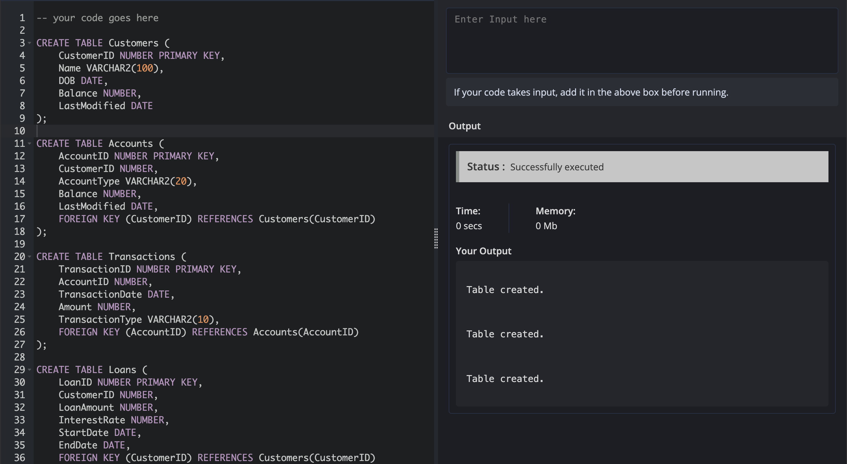

1. **Inserting the values**

**code:**

*INSERT INTO Customers (CustomerID, Name, DOB, Balance, LastModified)*

*VALUES (1, 'John Doe', TO_DATE('1985-05-15', 'YYYY-MM-DD'), 1000, SYSDATE);*

*INSERT INTO Customers (CustomerID, Name, DOB, Balance, LastModified)*

*VALUES (2, 'Jane Smith', TO_DATE('1990-07-20', 'YYYY-MM-DD'), 1500, SYSDATE);*

*INSERT INTO Accounts (AccountID, CustomerID, AccountType, Balance, LastModified)*

*VALUES (1, 1, 'Savings', 1000, SYSDATE);*

*INSERT INTO Accounts (AccountID, CustomerID, AccountType, Balance, LastModified)*

*VALUES (2, 2, 'Checking', 1500, SYSDATE);*

*INSERT INTO Transactions (TransactionID, AccountID, TransactionDate, Amount, TransactionType)*

*VALUES (1, 1, SYSDATE, 200, 'Deposit');*

*INSERT INTO Transactions (TransactionID, AccountID, TransactionDate, Amount, TransactionType)*

*VALUES (2, 2, SYSDATE, 300, 'Withdrawal');*

*INSERT INTO Loans (LoanID, CustomerID, LoanAmount, InterestRate, StartDate, EndDate)*

*VALUES (1, 1, 5000, 5, SYSDATE, ADD_MONTHS(SYSDATE, 60));*

*INSERT INTO Employees (EmployeeID, Name, Position, Salary, Department, HireDate)*

*VALUES (1, 'Alice Johnson', 'Manager', 70000, 'HR', TO_DATE('2015-06-15', 'YYYY-MM-DD'));*

*INSERT INTO Employees (EmployeeID, Name, Position, Salary, Department, HireDate)*

*VALUES (2, 'Bob Brown', 'Developer', 60000, 'IT', TO_DATE('2017-03-20', 'YYYY-MM-DD'));*

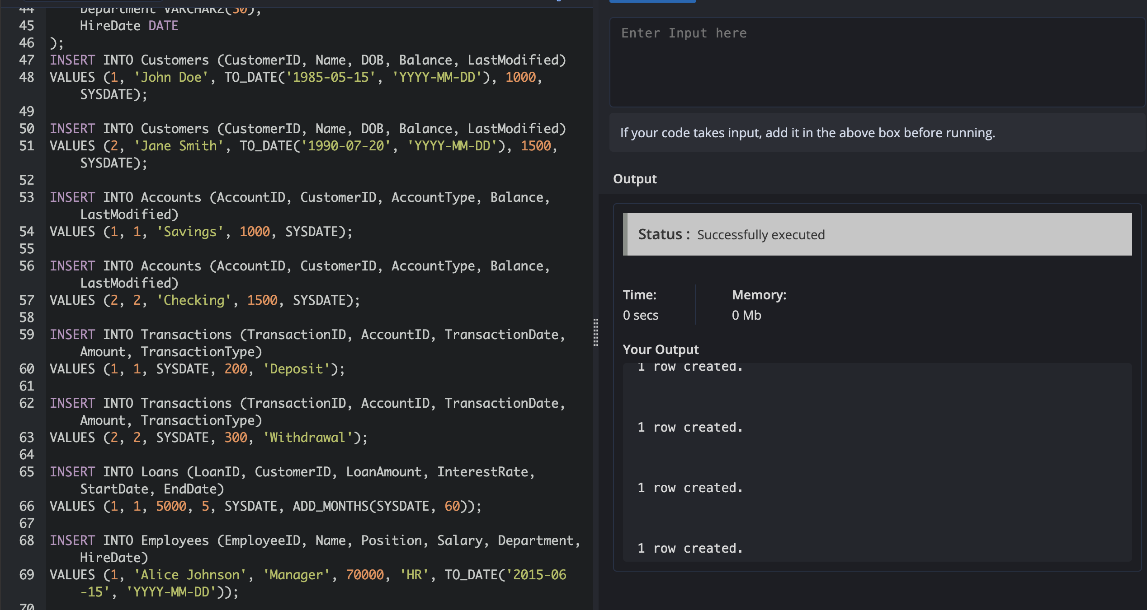

**Exercise 1: Control Structures**

**Scenario 1:** The bank wants to apply a discount to loan interest rates for customers above 60 years old.

* + **Question:** Write a PL/SQL block that loops through all customers, checks their age, and if they are above 60, apply a 1% discount to their current loan interest rates.

***code***

DECLARE

v_age NUMBER;

BEGIN

FOR c IN (SELECT CustomerID, DOB FROM Customers) LOOP

v_age := TRUNC(MONTHS_BETWEEN(SYSDATE, c.DOB) / 12);

IF v_age > 60 THEN

UPDATE Loans

SET InterestRate = InterestRate - 1

WHERE CustomerID = c.CustomerID;

END IF;

END LOOP;

COMMIT;

END;

/

***OUTPUT***

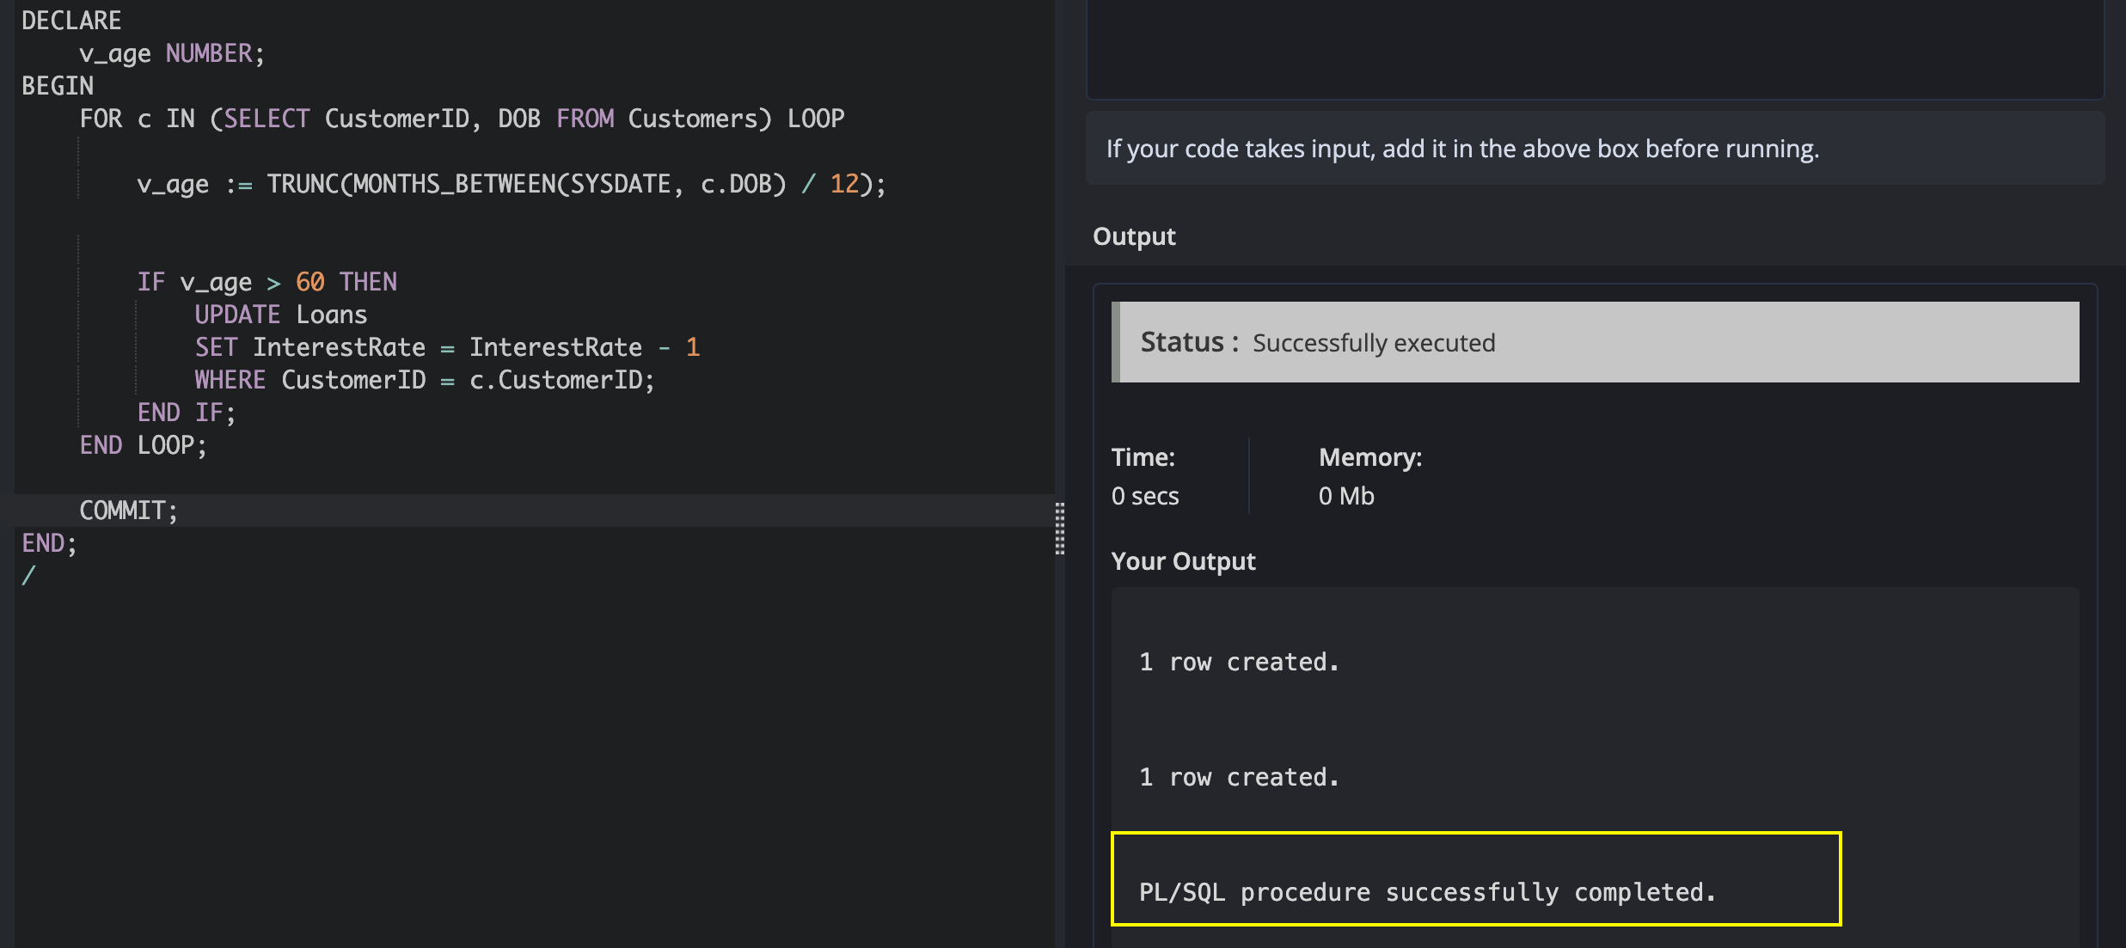

**Scenario 2:** A customer can be promoted to VIP status based on their balance.

* + **Question:** Write a PL/SQL block that iterates through all customers and sets a flag IsVIP to TRUE for those with a balance over $10,000.

**code**

ALTER TABLE Customers ADD IsVIP CHAR(1);

BEGIN

FOR c IN (SELECT CustomerID, Balance FROM Customers) LOOP

IF c.Balance > 10000 THEN

UPDATE Customers

SET IsVIP = 'Y'

WHERE CustomerID = c.CustomerID;

END IF;

END LOOP;

COMMIT;

END;

/

***output***

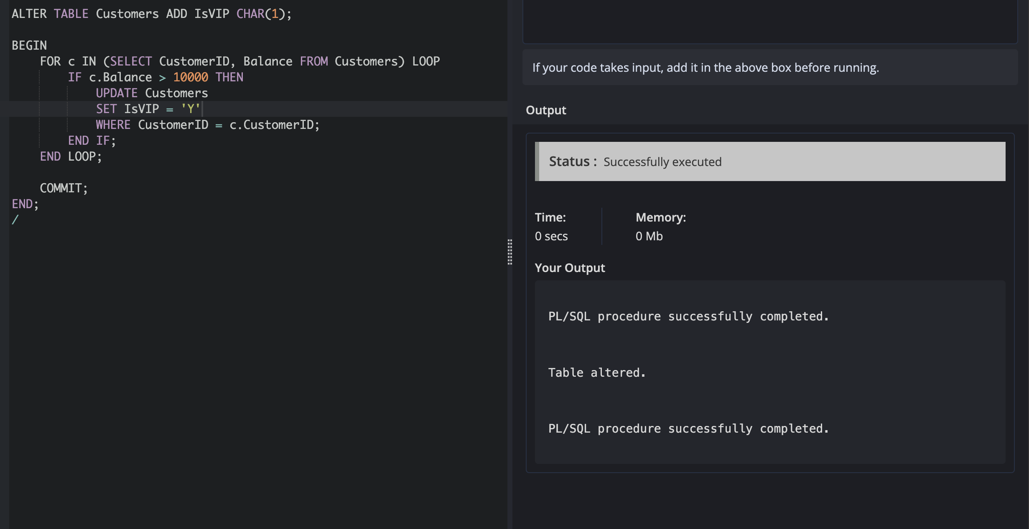

**Scenario 3:** The bank wants to send reminders to customers whose loans are due within the next 30 days.

**Question:** Write a PL/SQL block that fetches all loans due in the next 30 days and prints a reminder message for each customer.

DECLARE

v_name Customers.Name%TYPE;

v_due_date Loans.EndDate%TYPE;

BEGIN

FOR l IN (

SELECT LoanID, CustomerID, EndDate

FROM Loans

WHERE EndDate BETWEEN SYSDATE AND SYSDATE + 30

) LOOP

SELECT Name INTO v_name

FROM Customers

WHERE CustomerID = l.CustomerID;

v_due_date := l.EndDate;

DBMS_OUTPUT.PUT_LINE('Reminder: Loan ID ' || l.LoanID ||

' for ' || v_name ||

' is due on ' || TO_CHAR(v_due_date, 'DD-MON-YYYY'));

END LOOP;

END;

/

***OUTPUT***

